**Database Implementation**

**Calculating the optimal join cost**

* Please set the compiler version to C ++ 11 to run the project.

The project is in C ++ and consists of three files. The first file is the project header. We defined the necessary libraries and the required classes and functions in it.

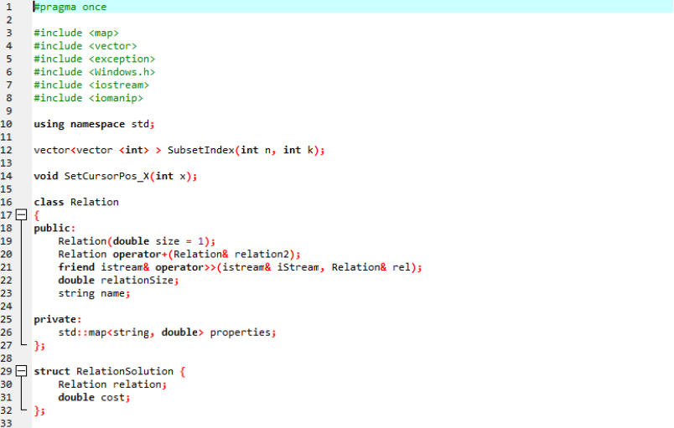

The second file is the relation.cpp file, which is for our connection and their connection. We also define two operators and two required functions here.

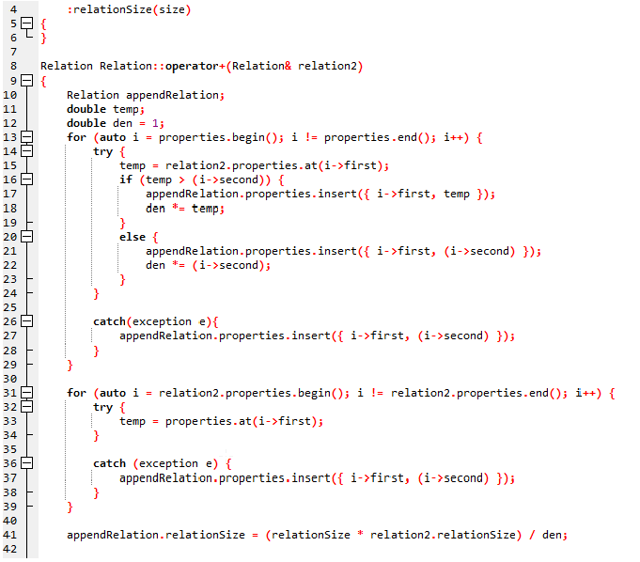

The main project file also consists of several loops in which we perform the operation of calculating the lowest Join cost. We also get the required items from the user.

